**TRINITY INTERNATIONAL SS & COLLEGE**

**Dillibazar Height, Kathmandu, Nepal**



**LAB REPORT # 6: Web Technology**

**(COMPUTER SCIENCE)**

**SUBMITTED BY: SUBMITTED TO:**

**NAME: Prashim Timsina**

**GRADE: XI (MC1)**

**DATE : [18th April 2023] PRAVEEN KOIRALA**

**Faculty of Computer Science**

**KATHMANDU, NEPAL**

**2022**

A Lab Work On

**Web Technology**

Submitted as a partial fulfillment of requirement of the curriculum of

GRADE-XI (Computer Science) under NEB

Submitted By:

**Prashim Timsina**

Under Supervision Of

**PRAVEEN KOIRALA**

Date:

**[18th April 2023]**



**TRINITY INTERNATIONAL SS & COLLEGE**

Dillibazar Height, Kathmandu, Nepal

ACKNOWLEDGEMENT

I would like to express my deep appreciation and gratitude to my subject teacher Mr. Praveen Koirala for his coinstantaneous help, advice, information and encouragement in this project.

I feel immense pleasure to present my project after a long work. Besides my effort, the help and guideline given by many others hasn’t been unnoticed. I express my gratitude to all those countless people for the support for me in doing this project.

I express my thanks to Trinity International College for it has been a source of the creation of this project and the support, valuable information, resources and guidance give to me to do this project.

I am also grateful and indebt of my beloved friends for their immeasurable help, support and encouragement from the beginning to the end of the project without whom this project would not have been a reality.

Last but not the least I would like to thank my parents, family members, friends, this College and other who help me for their guidance and support.

**[Prashim Timsina]**

**[18th April 2023]**

**TRINITY INTERNATIONAL SS & COLLEGE**

**Dillibazar Height, Kathmandu, Nepal**



**LAB WORK # 1: Web Technology (HTML & CSS)**

**(COMPUTER SCIENCE)**

**SUBMITTED BY: SUBMITTED TO:**

**NAME: Prashim Timsina**

**GRADE: XI (MC1)**

**DATE : [2080/01/05] PRAVEEN KOIRALA**

**Faculty of Computer Science**

**KATHMANDU, NEPAL**

**2022 Table of Contents**

S. No. Page No.

1. Acknowledgement I

2. Objectives II

3. Table of Contents III

4. Theoretical Background (1)

4.1 Web Technology

4.1.1 HTML

4.1.2 CSS

5. Work Done

6. Conclusion

7. Bibliography

8. Appendix

**2. Objective**

The main objectives of the lab work are as follows:

1. To understand HTML Tags and to create a skeleton page.
2. To understand HTML tags for Heading.
3. To understand HTML tags for Paragraph.
4. To understand HTML Text, Align Style.
5. To understand HTML Text Style.
6. To understand HTML Fonts attribute.
7. To understand HTML Marquee tag.
8. To understand HTML List.
9. To understand HTML Anchor element.
10. To understand HTML image element.
11. To understand HTML Table element.
12. To understand HTML Table element attributes.
13. To understand HTML Table element and its attributes.
14. To understand HTML Form Text Input control.
15. To understand HTML Form and different control.
16. To understand and add CSS to HTML Element.

**3. Theoretical Background**

HTML and CSS are two essential components of web development. HTML stands for Hypertext Markup Language, which is used to create web pages and applications. CSS stands for Cascading Style Sheets, which is used to define the visual appearance and layout of HTML documents.

HTML is a markup language that consists of a set of tags and attributes. These tags are used to structure content and define its meaning. HTML tags are surrounded by angle brackets, and each tag has a specific purpose. For example, the <head> tag is used to contain metadata about the page, while the <p> tag is used to define a paragraph.

CSS is used to control the presentation of HTML documents. It is used to specify the visual style of HTML elements, including their layout, fonts, colors, and backgrounds. CSS consists of a set of rules that define how HTML elements should be displayed. These rules can be defined inline, in the head section of the HTML document, or in a separate external file.

HTML and CSS work together to create a visually appealing and user-friendly website. HTML provides the structure and content of the page, while CSS provides the presentation and layout. By separating the content and presentation, HTML and CSS enable developers to create more accessible, maintainable, and efficient web pages.

Web developers use a variety of tools and techniques to create HTML and CSS documents. Text editors such as Notepad++ and Sublime Text are commonly used to create and edit HTML and CSS files. Integrated development environments (IDEs) such as Visual Studio Code and Adobe Dreamweaver provide more advanced features for web development, including code completion, debugging, and version control.

In addition to HTML and CSS, web developers use a variety of other technologies to create dynamic and interactive web applications. JavaScript is a programming language used to add interactivity and functionality to web pages. Frameworks and libraries such as React, Angular, and Vue.js provide pre-built components and tools for building web applications. Databases and server-side technologies such as MySQL, Node.js, and PHP are used to store and process data on the server side.

Overall, HTML and CSS are the foundational building blocks of web development. They enable developers to create web pages and applications that are both functional and visually appealing. As the web continues to evolve, new technologies and standards will emerge, but HTML and CSS will remain essential components of the web development stack.

**4. Work Done**

1. HTML page to view following lines in browser. ‘We are learning web page.’

Source Code:

<!DOCTYPE html>

<html>

<head>

<title>Learning Web Page</title>

</head>

<body>

<h1>We are learning web page.</h1>

</body>

</html>

Output:



2. To know about meta tags: meta charset, meta name(any three/four)

Source Code:

<!DOCTYPE html>

<html>

<head>

<meta charset="UTF-8">

<meta name="viewport" content="width=device-width, initial-scale=1.0">

<meta name="description" content="This is a brief description of my webpage.">

<meta name="keywords" content="HTML, CSS, JavaScript, web development">

<title>My Webpage</title>

</head>

<body>

<!-- Your webpage content here -->

</body>

</html>

Output: (No output)

3. HTML page with body attributes: top margin, bottom margin, bgcolor, text etc.

Source Code:

<!DOCTYPE html>

<html>

<head>

<title>Body Attributes</title>

</head>

<body style="margin-top: 50px; margin-bottom: 50px; background-color: #f2f2f2; color: #333;">

<h1>Body Attributes</h1>

<p>Lorem ipsum dolor sit amet, consectetur adipiscing elit. Sed non risus. Suspendisse lectus tortor, dignissim sit amet, adipiscing nec, ultricies sed, dolor.</p>

</body>

</html>

Output:

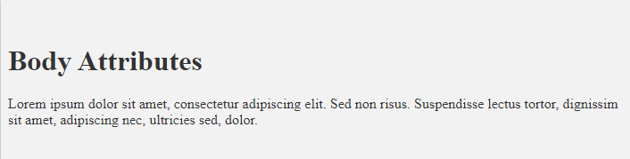

4. HTML page to set a body background image using attribute background.

Source Code:

<!DOCTYPE html>

<html>

<head>

<title>Background Image</title>

</head>

<body style="background-image: url('bg.jpg');">

<h1>Background Image</h1>

<p>Lorem ipsum dolor sit amet, consectetur adipiscing elit. Sed non risus. Suspendisse lectus tortor, dignissim sit amet, adipiscing nec, ultricies sed, dolor.</p>

</body>

</html>

Output:

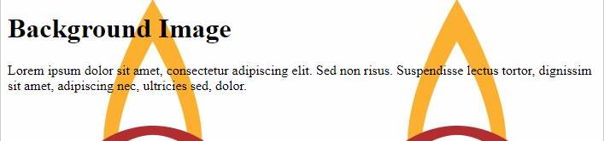

5. HTML page to insert any two images using tag <img> with attributes width, height, alt, title etc.

Source Code:

<!DOCTYPE html>

<html>

<head>

<title>Images</title>

</head>

<body>

<h1>Images</h1>

<img src="image1.jpg" alt="Image 1" title="Image 1" width="400" height="300">

<img src="image2.jpg" alt="Image 2" title="Image 2" width="400" height="300">

</body>

</html>

Output:



6. HTML page to play am audio sound using ‘object’ tag.

Source Code:

<!DOCTYPE html>

<html>

<head>

<title>Audio</title>

</head>

<body>

<h1>Audio</h1>

<object data="audio.mp3" type="audio/mp3">

<param name="autoplay" value="true">

</object>

</body>

</html>

Output:

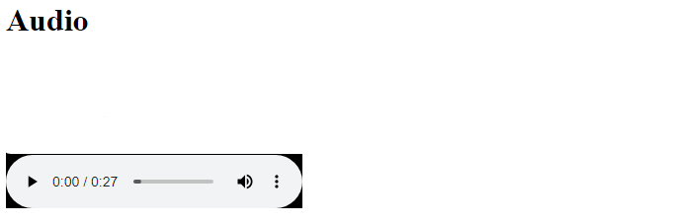

7. HTML page to play an audio file using tag ‘audio’ and attributes ‘src’,type.

Source Code:

<!DOCTYPE html>

<html>

<head>

<title>Audio</title>

</head>

<body>

<h1>Audio</h1>

<audio controls>

<source src="audio.mp3" type="audio/mp3">

Your browser does not support the audio element.

</audio>

</body>

</html>

Output: (same as above)

8. HTML page to know about different heading tags( h1,h2,h3,h4,h5 and h6) with attributes align.

Source Code:

<!DOCTYPE html>

<html>

<head>

<title>Heading tags example</title>

</head>

<body>

<h1 align="center">Heading 1</h1>

<h2 align="left">Heading 2</h2>

<h3 align="right">Heading 3</h3>

<h4 align="justify">Heading 4</h4>

<h5 align="center">Heading 5</h5>

<h6 align="left">Heading 6</h6>

</body>

</html>

Output:

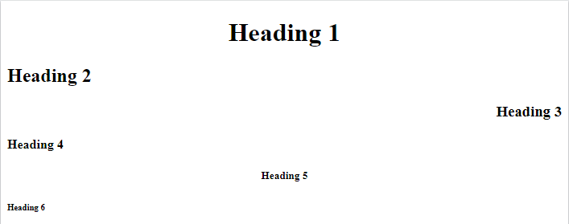

9. HTML page to know about following formatting tags.

B,I, U, sup,sub,strike,del,mark,strong,em,small,big,ins,pre etc

Source Code:

<!DOCTYPE html>

<html>

<head>

<title>Formatting tags example</title>

</head>

<body>

<b>Bold text</b><br>

<i>Italic text</i><br>

<u>Underline text</u><br>

<sup>Superscript text</sup><br>

<sub>Subscript text</sub><br>

<strike>Strike text</strike><br>

<del>Deleted text</del><br>

<mark>Highlighted text</mark><br>

<strong>Strong text</strong><br>

<em>Emphasized text</em><br>

<small>Small text</small><br>

<big>Big text</big><br>

<ins>Inserted text</ins><br>

<pre>Preformatted text</pre>

</body>

</html>

Output:

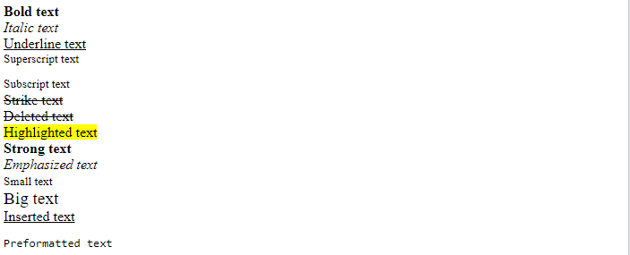

10. HTML page to know about ‘font’ tag with attributes size,font face,color etc.

Source Code:

<!DOCTYPE html>

<html>

<head>

<title>Font tag example</title>

</head>

<body>

<font size="5" face="Arial" color="red">This is a red Arial text with size 5</font><br>

<font size="3" face="Times New Roman" color="blue">This is a blue Times New Roman text with size 3</font><br>

<font size="2" face="Verdana" color="green">This is a green Verdana text with size 2</font>

</body>

</html>

Output:



11. HTML page to be familiar with tag ‘basefont’ and attributes color,size,face etc.

The <basefont> tag is deprecated in HTML5 and should not be used.

12. HTML page to be familiar with tag ‘p’ and attributes align and values left,right ,center etc. Use ‘br’ tags.

Source Code:

<!DOCTYPE html>

<html>

<head>

<title>Paragraph tag example</title>

</head>

<body>

<p align="left">This is a left-aligned paragraph.<br>

This is the second line.</p>

<p align="center">This is a center-aligned paragraph.<br>

This is the second line.</p>

<p align="right">This is a right-aligned paragraph.<br>

This is the second line.</p>

</body>

</html>

Output:

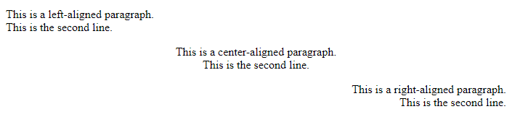

13. HTML PAGE TO COMMENT CERTAIN PART.

Source Code:

<!DOCTYPE html>

<html>

<head>

<title>Comment Example</title>

</head>

<body>

<h1>Welcome to my web page!</h1>

<p>This is a paragraph of text.</p>

<!-- <p>This is a commented out paragraph of text.</p> -->

<p>Here is another paragraph of text.</p>

</body>

</html>

Output: (No Output)

14. HTML PAGE TO know about ‘marquee’ tag with attributes behavior, direction, bgcolor, height, loop, scroll amount, scrolldelay, vspace, width.

Source Code:

<!DOCTYPE html>

<html>

<head>

<title>Marquee Example</title>

</head>

<body>

<marquee behavior="scroll" direction="left" bgcolor="#FF0000" height="50" loop="2" scrollamount="5" scrolldelay="100" vspace="10" width="500">

<p>This is a scrolling text example using the marquee tag.</p>

</marquee>

</body>

</html>

Output:



15. Use following list to create different numbering and bulleting styles.

1) For definition list. 2) For ordered list(with different attributes start, type)

3) For unordered list(“ ”). 4) For nested list(using ol,ul)

Source Code:

<!DOCTYPE html>

<html>

<head>

<title>List Examples</title>

</head>

<body>

<h2>Definition List Example</h2>

<dl>

<dt>HTML</dt>

<dd>Hyper Text Markup Language</dd>

<dt>CSS</dt>

<dd>Cascading Style Sheets</dd>

<dt>JS</dt>

<dd>JavaScript</dd>

</dl>

<h2>Ordered List Example</h2>

<ol start="3" type="A">

<li>First Item</li>

<li>Second Item</li>

<li>Third Item</li>

<li>Fourth Item</li>

</ol>

<h2>Unordered List Example</h2>

<ul>

<li>Item One</li>

<li>Item Two</li>

<li>Item Three</li>

</ul>

<h2>Nested List Example</h2>

<ol>

<li>Main Item 1

<ul>

<li>Sub Item 1</li>

<li>Sub Item 2</li>

</ul>

</li>

<li>Main Item 2</li>

<li>Main Item 3

<ol>

<li>Sub Item 1</li>

<li>Sub Item 2</li>

<li>Sub Item 3</li>

</ol>

</li>

</ol>

</body>

</html>

Output:

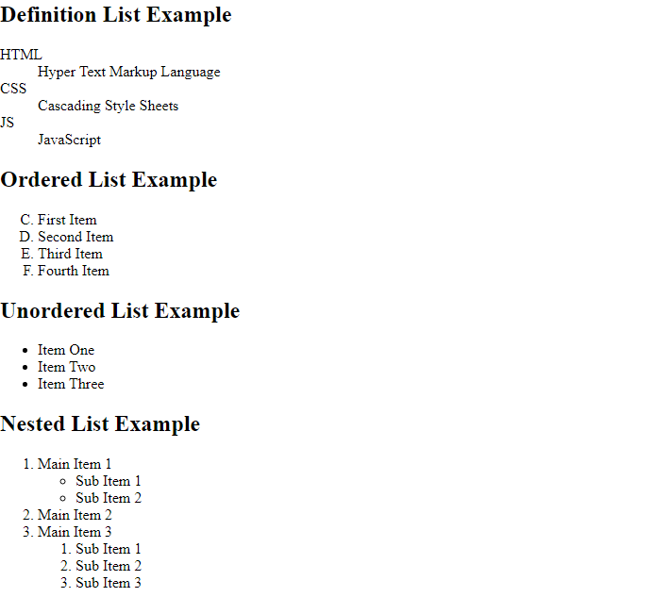

16. HTML page to know about ‘address’ tag.

Source Code:

<!DOCTYPE html>

<html>

<head>

<title>Address Tag Example</title>

</head>

<body>

<h1>My Contact Information</h1>

<address>

<p>Name: John Doe</p>

<p>Email: johndoe@example.com</p>

<p>Phone: 123-456-7890</p>

</address>

</body>

</html>

Output:

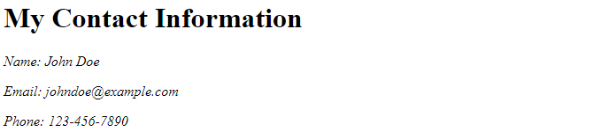

17. HTML page to be familiar with hyperlinks. Also talk about different types(local/internal, external)

Source Code:

<!DOCTYPE html>

<html>

<head>

<title>Local Link Example</title>

</head>

<body>

<h1>Local Link Example</h1>

<a href="about.html">About Us</a>

<a href="https://www.example.com">About Us</a>

</body>

</html>

Output:

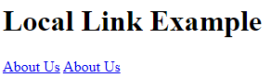

18. HTML page to create tables with different attributes such as align, bgcolor,border,bordercolor,cellpadding,cellspacing,width,height.rowspan,colspan. Also use tags th,tr,td ,caption etc.

Source Code:

<!DOCTYPE html>

<html>

<head>

<title>Table Example</title>

</head>

<body>

<table border="1" cellpadding="5" cellspacing="0" width="80%" align="center" bgcolor="#efefef">

<caption><strong>Employee Details</strong></caption>

<tr>

<th colspan="2" bgcolor="#d9d9d9">Personal Information</th>

<th rowspan="2" bgcolor="#d9d9d9">Contact Information</th>

</tr>

<tr>

<td>Name:</td>

<td>John Doe</td>

</tr>

<tr>

<td>Age:</td>

<td>30</td>

<td rowspan="3" bgcolor="#d9d9d9">Email: john.doe@example.com<br>Phone: 123-456-7890</td>

</tr>

<tr>

<td>Gender:</td>

<td>Male</td>

</tr>

<tr>

<td>Address:</td>

<td>123 Main St</td>

</tr>

</table>

</body>

</html>

Output:

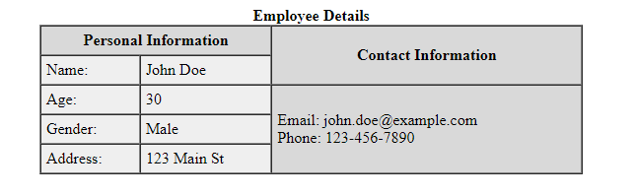

19. To be familiar with form tag with different elements:

input type: textbox,radio,checkbox,password,file,button,submit,reset,textarea,select.optgroup,fieldset,label,email,color etc

Source Code:

<!DOCTYPE html>

<html>

<head>

<title>Form Elements</title>

</head>

<body>

<form>

<label for="name">Name:</label>

<input type="text" id="name" name="name"><br>

<label for="email">Email:</label>

<input type="email" id="email" name="email"><br>

<label for="password">Password:</label>

<input type="password" id="password" name="password"><br>

<label for="file">File:</label>

<input type="file" id="file" name="file"><br>

<label for="checkbox">Checkbox:</label>

<input type="checkbox" id="checkbox" name="checkbox"><br>

<label for="radio">Radio:</label>

<input type="radio" id="radio" name="radio"><br>

<label for="submit">Submit:</label>

<input type="submit" id="submit" name="submit"><br>

<label for="reset">Reset:</label>

<input type="reset" id="reset" name="reset"><br>

<label for="button">Button:</label>

<input type="button" id="button" name="button"><br>

<label for="textarea">Textarea:</label>

<textarea id="textarea" name="textarea"></textarea><br>

<label for="select">Select:</label>

<select id="select" name="select">

<option value="option1">Option 1</option>

<option value="option2">Option 2</option>

<option value="option3">Option 3</option>

</select><br>

<label for="optgroup">Optgroup:</label>

<select id="optgroup" name="optgroup">

<optgroup label="Group 1">

<option value="option1">Option 1</option>

<option value="option2">Option 2</option>

</optgroup>

<optgroup label="Group 2">

<option value="option3">Option 3</option>

<option value="option4">Option 4</option>

</optgroup>

</select><br>

<fieldset>

<legend>Legend</legend>

<label for="fieldset">Fieldset:</label>

<input type="text" id="fieldset" name="fieldset"><br>

</fieldset>

</form>

</body>

</html>

Output:

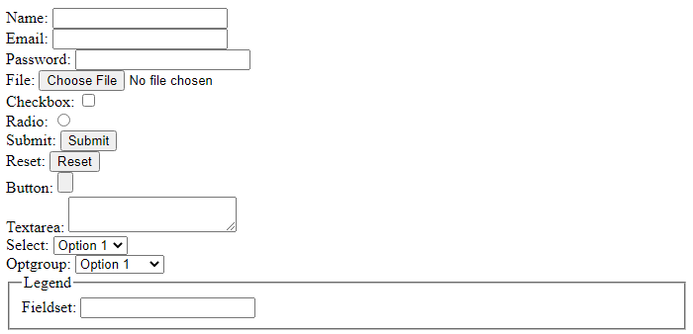

20. Working with frameset tag and attributescols,rows.

Creating different columns, rows and creating links.

Working with iframe tag.

Source Code:

<!DOCTYPE html>

<html>

<head>

<title>Frameset</title>

</head>

<frameset cols="25%,75%">

<frame src="w3error.html">

<frame src="w3error.html">

</frameset>

</html>

Output:

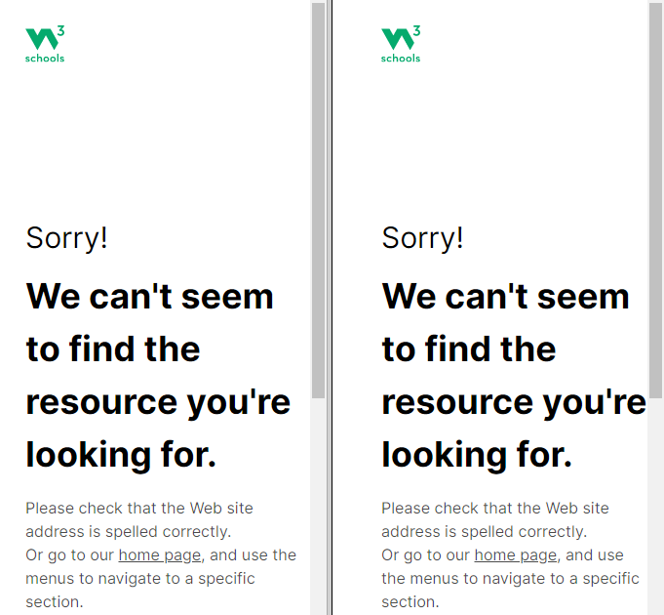

21.1 Audio, video, object, embed, etc. with attributes src, data, type etc

Source Code:

<!DOCTYPE html>

<html>

<head>

<title>Audio, Video, Object, and Embed Example</title>

</head>

<body>

<h1>Audio, Video, Object, and Embed Example</h1>

<!-- Audio Tag -->

<audio controls>

<source src="audio.mp3" type="audio/mpeg">

<source src="audio.ogg" type="audio/ogg">

Your browser does not support the audio element.

</audio>

<!-- Video Tag -->

<video width="320" height="240" controls>

<source src="video.mp4" type="video/mp4">

<source src="video.ogg" type="video/ogg">

Your browser does not support the video element.

</video>

<!-- Object Tag -->

<object type="application/pdf" data="document.pdf" width="100%" height="500">

<p>Alternative text for the object.</p>

<p><a href="document.pdf">Download the PDF file.</a></p>

</object>

<!-- Embed Tag -->

<embed src="animation.swf" type="application/x-shockwave-flash" width="550" height="400">

</body>

</html>

Output:

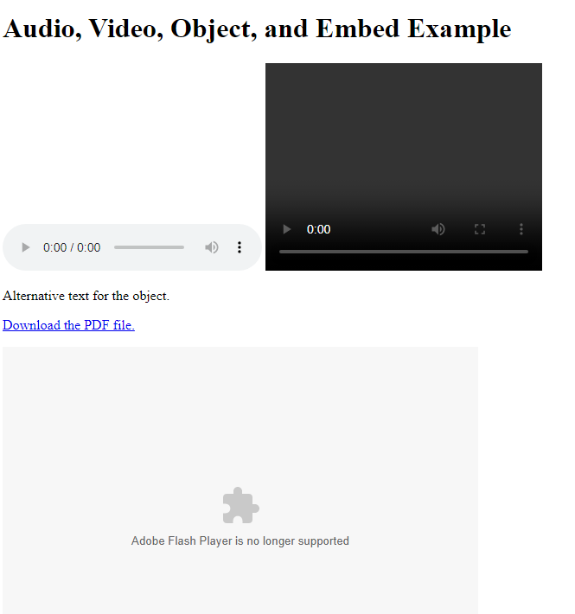

21.2 canvas tag with attributes id,width,height etc.

Source Code:

<!DOCTYPE html>

<html>

<head>

<title>Canvas Example</title>

</head>

<body>

<canvas id="myCanvas" width="400" height="400"></canvas>

<script>

const canvas = document.getElementById('myCanvas');

const ctx = canvas.getContext('2d');

ctx.fillStyle = 'red';

ctx.fillRect(50, 50, 100, 100);

</script>

</body>

</html>

Output:



21.2 'svg' tag with attributes height, width.

[Note: Let's give any two examples of canvas and svg.]

Source Code:

<!DOCTYPE html>

<html>

<head>

<title>SVG Example</title>

</head>

<body>

<svg width="400" height="400">

<rect x="50" y="50" width="300" height="300" fill="blue" />

<circle cx="200" cy="200" r="100" fill="yellow" />

<line x1="50" y1="200" x2="350" y2="200" stroke="red" stroke-width="5" />

</svg>

</body>

</html>

Output:

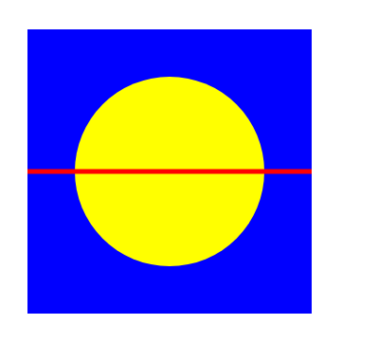

22. CSS

Source Code:

<!DOCTYPE html>

<html>

<head>

<title>My HTML/CSS Example</title>

<style type="text/css">

/* CSS introduction */

h1 {

color: blue;

text-align: center;

}

/* CSS working methods */

/* inline */

span {

font-weight: bold;

}

/* internal */

style {

color: red;

}

/* external */

/* style.css file */

/* CSS syntax with selectors */

/* id */

#main {

background-color: yellow;

border: 1px solid black;

padding: 10px;

}

/* element */

p {

margin-bottom: 20px;

}

/* class */

.intro {

font-size: 18px;

}

/* grouping */

h2, h3 {

color: green;

margin-top: 30px;

margin-bottom: 10px;

}

/* universal */

* {

box-sizing: border-box;

}

/* CSS comments */

/* this is a comment */

/* Styling the html page with CSS */

/* Use different elements with attributes */

/* Height, width */

img {

height: 200px;

width: 200px;

}

/* background */

body {

background-color: lightgray;

}

/* text-align */

p {

text-align: justify;

}

/* font size */

h1 {

font-size: 36px;

}

/* borders */

.intro {

border: 2px solid black;

padding: 10px;

}

/* margin */

p {

margin: 10px;

}

/* padding */

#main {

padding: 20px;

}

/* float */

.left {

float: left;

margin-right: 10px;

}

.right {

float: right;

margin-left: 10px;

}

/* navigation */

nav {

background-color: navy;

color: white;

padding: 10px;

text-align: center;

}

nav a {

color: white;

text-decoration: none;

margin-right: 20px;

}

/* text decoration */

a {

text-decoration: none;

color: blue;

}

a:hover {

text-decoration: underline;

}

/* inline/block */

span {

display: inline-block;

width: 100px;

background-color: yellow;

padding: 10px;

margin-right: 10px;

}

span:last-child {

margin-right: 0;

}

</style>

</head>

<body>

<header>

<h1>My HTML/CSS Example</h1>

<nav>

<a href="#">Home</a>

<a href="#">About</a>

<a href="#">Contact</a>

</nav>

</header>

<main>

<div id="main">

<h2>Welcome to my website</h2>

<p class="intro">Lorem ipsum dolor sit amet, consectetur adipiscing elit. Suspendisse sit amet risus quis ipsum luctus</p>

<p>Lorem ipsum dolor sit amet, consectetur adipiscing elit. Suspendisse sit amet risus quis ipsum luctus consequat sed ac eros. Nullam quis risus auctor, faucibus ligula vitae, pharetra nisi. Integer eu risus nec enim commodo faucibus.</p>

<img src="https://via.placeholder.com/200" alt="placeholder image">

<div class="intro">This is an introduction.</div>

<h3>Heading Three</h3>

<p>Lorem ipsum dolor sit amet, consectetur adipiscing elit. Suspendisse sit amet risus quis ipsum luctus consequat sed ac eros.</p>

<h3>Another Heading Three</h3>

<p>Lorem ipsum dolor sit amet, consectetur adipiscing elit. Suspendisse sit amet risus quis ipsum luctus consequat sed ac eros.</p>

<span>Span 1</span>

<span>Span 2</span>

<span>Span 3</span>

<div class="left">

<p>Left Column</p>

</div>

<div class="right">

<p>Right Column</p>

</div>

</div>

</main>

<footer>

<p>&copy; 2023 My Company</p>

</footer>

</body>

</html>

Output:

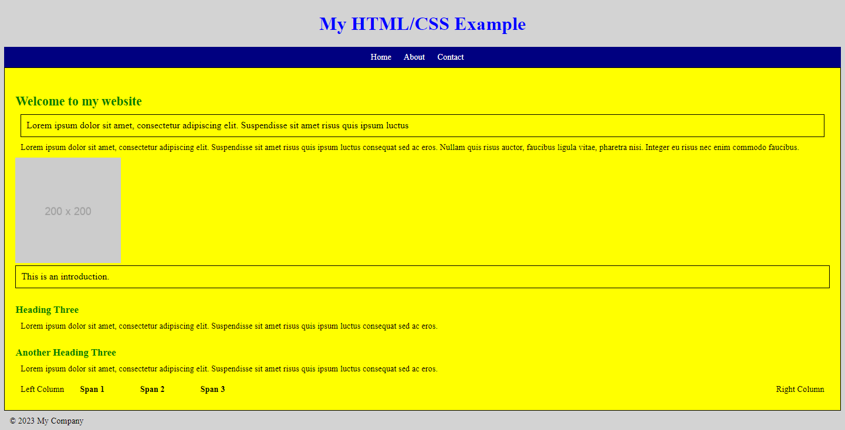

CONCLUSION

In conclusion, the lab report has explored the fundamentals of HTML and CSS, which are two critical components of web development. HTML is the markup language used to create the structure and content of web pages, while CSS is used for styling and presentation. The report has covered a wide range of topics, from basic tags and attributes to more advanced concepts like forms, tables, and multimedia elements.

Throughout the lab, we have learned how to use HTML to create a well-structured and accessible website. We have also seen how CSS can be used to enhance the design and visual appeal of web pages, including techniques like layout, typography, and color schemes. By applying these principles, we can create websites that are not only functional but also aesthetically pleasing and engaging for users.

Overall, this lab has provided us with a solid foundation in HTML and CSS, which are essential skills for anyone interested in web development. With continued practice and exploration, we can build on this foundation and create increasingly complex and sophisticated web projects.